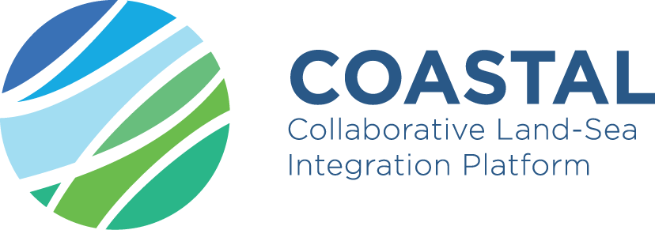
773782-COASTAL Co-creating business road maps and policy guidelines for coastal-rural development

Existing research still primarily addresses coastal systems from either a land- or sea-based perspective, making policies based on that research ill-adapted to support effective land-sea integration at the local, regional and macro-regional scale. As a result, rural and coastal development do not yet fully benefit from opportunities which could foster synergistic economic development. The aim of the H2020 project COASTAL (https://h2020-coastal.eu) is to identify these opportunities by improved understanding of the social-ecological land-sea interactions. To this end coastal and rural stakeholders interacted with environmental and social experts in six Multi-Actor Labs all over the EU. Mind maps, causal loop diagrams and stock-flow models are being used to support the design of evidence-based business road maps and policy guidelines.
While causal loops provide a qualitative analysis of the problems at hand, stock-flow modelling can be used to provide quantitative answers. Stock flow modelling and System Dynamics (SD) modelling arose in the late 1950s to examine problems from the underlying feedback structure of systems. The approach can be used, for example, to explain why certain start-up businesses fail, whereas others do not under similar circumstances, or why the short-term and long-term impact of strategic decisions can be different. Although the human brain is capable of providing part of the answer this becomes more difficult when multiple factors play a role. This is certainly true for complex social-environmental systems such as coastal regions which are densely used and rapidly developing, with economic activities competing for resources such as space, water, energy and skilled labor. Typical strengths are the graphical, transparent nature of the models allowing interactive design with stakeholders, high computing speeds and the limited data requirements. Nevertheless, the design and calibration of these models can be difficult, particularly when stakeholder engagements result in overly complex or ill-balanced causal loop diagrams. The main challenges faced are: (1) to properly align qualitative and quantitative analysis, (2) to ensure alignment with existing and planned development strategies, and (3) to engage stakeholders directly throughout all phases of the project. The stakeholders, actor and research partners collaborated intensely to further develop their models and collect the supporting data. All Multi-Actor Labs completed their second round of stakeholder engagements by the end of February 2021. Currently, the project teams are completing their pilot system models. The outcomes of the stakeholder engagements are being translated into tutorial models for visualizing transition pathways and scenarios. These will help make policy and business recommendations evidence-based. Stakeholder expertise can be used to gain understanding of the rural-coastal system feedback and interactions between the different sectors. These models will be used to evaluate different scenarios for rural development, including best practices. Topics range from aquaculture, sustainable water management, eco farming and rural tourism to the decommissioning of offshore wind farms and are examined in an integrated manner to address the objectives of EU Directives such as the Green Deal.
Results and practical lessons to be drawn are being collected in so-called “practice abstracts”, to be found online on the website of EIP-AGRI and newsletters on the project website. Two methodological lessons to be drawn from the systems modelling exercise are that stakeholders are best engaged in the co-creation process by focusing on the policy implications rather than the underlying model details, and that system archetypes and operational examples are very useful for supporting the translation of causal loop diagrams into stock-flow models. In November 18, 2021, the COASTAL coordination team of VITO interacted in an online meeting with the coordination team of the ROBUST sister project, coordinated by the Department of Rural Sociology of Wageningen University, the Netherlands, to discuss complementary aspects and differences in methodology and opportunities for joint dissemination actions.

Sterman John D. Business Dynamics: Systems Thinking and Modelling for a Complex World, McGraw Hill, 2000.

